**Project No.2**

Yongchi Zhang

When doing Project 2, I use MySQL version 5.6 at first. However, this version of MySQL doesn't yet support multiple triggers with the same action time and event for one table.

So, I need to combine the trigger of Question 1, trigger of Question 4 and trigger of Question 6 into a new trigger.

Then I use MySQL version 5.7.16, which supports multiple triggers with the same action time and event for one table. It’s convenient.

Question 1

Establish the trigger:

|  |
| --- |
| delimiter $$  drop trigger if exists movie_category_insert $$  create trigger movie_category_insert  before insert on made_money  for each row  begin  if new.Category!='Romantic' and new.Category!='Comedy' and new.Category!='Drama' and new.Category!='Action' then  set new.Category='Action';  end if;  end $$  delimiter $$  drop trigger if exists movie_category_update $$  create trigger movie_category_update  before update on made_money  for each row  begin  if new.Category!='Romantic' and new.Category!='Comedy' and new.Category!='Drama' and new.Category!='Action' then  set new.Category='Action';  end if;  end $$  delimiter ; |

Question 2

Establish the trigger:

|  |
| --- |
| delimiter $$  **drop** **trigger** **if** **exists** star_movie $$  **create** **trigger** star_movie  **before** **insert** **on** appeared_in  **for** **each** **row**  **begin**  **if** **not** **exists**  **(**  **select** **\***  **from** appeared_in t1**,** made_money t2  **where** t1**.**star**=new.**star **and**  t1**.**movie**=**t2**.**movie **and**  **(select** DAY_OPENED **from** made_money **where** movie**=new.**movie**)** **>** t2**.**DAY_OPENED **and**  t2**.**category **in** **(**'Romantic'**,**'Drama'**,**'Comedy'**)**  **)**  **then**  **update** made_money **as** t3  **set** t3**.**category**=**'Drama'  **where** t3**.**movie**=new.**movie**;**  **end** **if;**  **end** $$  delimiter **;** |

Question 3

Establish the trigger:

|  |
| --- |
| delimiter $$  **drop** **trigger** **if** **exists** star_married $$  **create** **trigger** star_married  **before** **insert** **on** married  **for** **each** **row**  **begin**  **declare** dday **date;**  **declare** done **int** **default** -1**;**  **declare** mycursor **cursor** **for**  **(select** t3**.day** **as** divorce_day  **from** **(**in_couple t1**,** married t2**)** **left** **outer** **join** divorced t3  **on** t2**.**COUPLE_NUM**=**t3**.**COUPLE_NUM  **where** t1**.**star **in** **(select** star **from** in_couple **where** COUPLE_NUM**=new.**couple_num**)** **and**  t1**.**COUPLE_NUM**=**t2**.**COUPLE_NUM **);**  **declare** **continue** handler **for** **not** **found** **set** done**=**1**;**  **open** mycursor**;**  checkloop**:loop**  **fetch** mycursor **into** dday**;**  **if** **(**done**=**1**)** **then**  leave checkloop**;**  **end** **if;**  **if** **(**dday **is** **null** **or** **new.day<**dday**)** **then**  SIGNAL **SQLSTATE** '45000'  **set** MESSAGE_TEXT **=**'Cannot insert data because of the constraint: A star cannot be married to multiple stars simultaneously.'**;**  leave checkloop**;**  **end** **if;**  **end** **loop** checkloop**;**  **end** $$  delimiter **;** |

Question 4

Establish the trigger:

|  |
| --- |
| delimiter $$  **drop** **trigger** **if** **exists** boxoffice_constraint $$  **create** **trigger** boxoffice_constraint  **before** **insert** **on** made_money  **for** **each** **row**  **begin**  **if(new.**category**=**'Action' **and** **new.**how_much**<**10000**)** **then**  SIGNAL **SQLSTATE** '45000'  **set** MESSAGE_TEXT **=**'Cannot insert data because of the box office constraint.'**;**  elseif**(new.**category**=**'Comedy' **and** **new.**how_much**>**1000000000**)** **then**  SIGNAL **SQLSTATE** '45000'  **set** MESSAGE_TEXT **=**'Cannot insert data because of the box office constraint.'**;**  elseif**(new.**how_much**<**1000 **or** **new.**how_much**>**3000000000**)** **then**  SIGNAL **SQLSTATE** '45000'  **set** MESSAGE_TEXT **=**'Cannot insert data because of the box office constraint.'**;**  **end** **if;**  **end** $$  **drop** **trigger** **if** **exists** boxoffice_constraint_update $$  **create** **trigger** boxoffice_constraint_update  **before** **update** **on** made_money  **for** **each** **row**  **begin**  **if(new.**category**=**'Action' **and** **new.**how_much**<**10000**)** **then**  SIGNAL **SQLSTATE** '45000'  **set** MESSAGE_TEXT **=**'Cannot insert data because of the box office constraint.'**;**  elseif**(new.**category**=**'Comedy' **and** **new.**how_much**>**1000000000**)** **then**  SIGNAL **SQLSTATE** '45000'  **set** MESSAGE_TEXT **=**'Cannot insert data because of the box office constraint.'**;**  elseif**(new.**how_much**<**1000 **or** **new.**how_much**>**3000000000**)** **then**  SIGNAL **SQLSTATE** '45000'  **set** MESSAGE_TEXT **=**'Cannot insert data because of the box office constraint.'**;**  **end** **if;**  **end** $$  delimiter **;** |

Trigger of Question 4 and trigger of Question 1 are both triggered by the insertion of table made_money. However, this version of MySQL doesn't yet support multiple triggers with the same action time and event for one table.

So, we need to combine the trigger of Question 4 and trigger of Question 1 into a new trigger.

|  |
| --- |
| delimiter $$  **drop** **trigger** **if** **exists** mademoney_constraint_insert $$  **create** **trigger** mademoney_constraint_insert  **before** **insert** **on** made_money  **for** **each** **row**  **begin**  if new.Category!='Romantic' and new.Category!='Comedy' and new.Category!='Drama' and new.Category!='Action'  then  set new.Category='Action';  end if;  **if(new.**category**=**'Action' **and** **new.**how_much**<**10000**)** **then**  SIGNAL **SQLSTATE** '45000'  **set** MESSAGE_TEXT **=**'Cannot insert data because of the box office constraint.'**;**  elseif**(new.**category**=**'Comedy' **and** **new.**how_much**>**1000000000**)** **then**  SIGNAL **SQLSTATE** '45000'  **set** MESSAGE_TEXT **=**'Cannot insert data because of the box office constraint.'**;**  elseif**(new.**how_much**<**1000 **or** **new.**how_much**>**3000000000**)** **then**  SIGNAL **SQLSTATE** '45000'  **set** MESSAGE_TEXT **=**'Cannot insert data because of the box office constraint.'**;**  **end** **if;**  **end** $$  **drop** **trigger** **if** **exists** mademoney_constraint_update $$  **create** **trigger** mademoney_constraint_update  **before** **update** **on** made_money  **for** **each** **row**  **begin**  if new.Category!='Romantic' and new.Category!='Comedy' and new.Category!='Drama' and new.Category!='Action'  then  set new.Category='Action';  end if;  **if(new.**category**=**'Action' **and** **new.**how_much**<**10000**)** **then**  SIGNAL **SQLSTATE** '45000'  **set** MESSAGE_TEXT **=**'Cannot insert data because of the box office constraint.'**;**  elseif**(new.**category**=**'Comedy' **and** **new.**how_much**>**1000000000**)** **then**  SIGNAL **SQLSTATE** '45000'  **set** MESSAGE_TEXT **=**'Cannot insert data because of the box office constraint.'**;**  elseif**(new.**how_much**<**1000 **or** **new.**how_much**>**3000000000**)** **then**  SIGNAL **SQLSTATE** '45000'  **set** MESSAGE_TEXT **=**'Cannot insert data because of the box office constraint.'**;**  **end** **if;**  **end** $$  delimiter **;** |

Actually, the trigger of Question 6 is also triggered by the insertion of table made_money. I will combine them all finally, on the next next page.

Question 5

Establish the trigger:

|  |
| --- |
| delimiter $$  **drop** **trigger** **if** **exists** divorce_constraint_insert $$  **create** **trigger** divorce_constraint_insert  **before** **insert** **on** divorced  **for** **each** **row**  **begin**  **if** **(new.day** **<** **(** **select** t1**.day**  **from** married t1  **where** t1**.**couple_num **=** **new.**couple_num **)** **)**  **then**  **set** **new.day** **=** **(** **select** t2**.day**  **from** married t2  **where** t2**.**couple_num **=** **new.**couple_num **);**  **end** **if;**  **end** $$  **drop** **trigger** **if** **exists** divorce_constraint_update $$  **create** **trigger** divorce_constraint_update  **before** **update** **on** divorced  **for** **each** **row**  **begin**  **if** **(new.day** **<** **(** **select** t1**.day**  **from** married t1  **where** t1**.**couple_num **=** **new.**couple_num **)** **)**  **then**  **set** **new.day** **=** **(** **select** t2**.day**  **from** married t2  **where** t2**.**couple_num **=** **new.**couple_num **);**  **end** **if;**  **end** $$  delimiter **;** |

Question 6

Trigger of Question 1, trigger of Question 4 and trigger of Question 6 are both triggered by the insertion of table made_money. However, this version of MySQL doesn't yet support multiple triggers with the same action time and event for one table.

So, we need to combine the trigger of Question 1, the trigger of Question 4 and trigger of Question 6 into a new trigger.

|  |
| --- |
| delimiter $$  **drop** **trigger** **if** **exists** mademoney_constraint_insert $$  **create** **trigger** mademoney_constraint_insert  **before** **insert** **on** made_money  **for** **each** **row**  **begin**  **if** **new.**Category**!=**'Romantic' **and** **new.**Category**!=**'Comedy' **and** **new.**Category**!=**'Drama' **and** **new.**Category**!=**'Action'  **then**  **set** **new.**Category**=**'Action'**;**  **end** **if;**  **if(new.**category**=**'Action' **and** **new.**how_much**<**10000**)** **then**  SIGNAL **SQLSTATE** '45000'  **set** MESSAGE_TEXT **=**'Cannot insert data because of the box office constraint.'**;**  elseif**(new.**category**=**'Comedy' **and** **new.**how_much**>**1000000000**)** **then**  SIGNAL **SQLSTATE** '45000'  **set** MESSAGE_TEXT **=**'Cannot insert data because of the box office constraint.'**;**  elseif**(new.**how_much**<**1000 **or** **new.**how_much**>**3000000000**)** **then**  SIGNAL **SQLSTATE** '45000'  **set** MESSAGE_TEXT **=**'Cannot insert data because of the box office constraint.'**;**  **end** **if;**  **insert** **into** log_data **values(new.**movie**,new.**category**);**  **end** $$ |

**Results**

a) Insert a new movie, with values (“IRON MAN”, 1000000, 2008-05-02, “ACTON”) in MADE_MONEY table.

|  |
| --- |
| **insert** **into** made_money **values(**'IRON MAN'**,** 1000000**,** 20080502**,** 'ACTON'**);** |

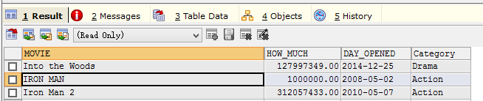

b) Update the CATEGORY of the movie “Fight Club” to “Horror” in MADE_MONEY table.

|  |
| --- |
| **update** made_money **set** Category**=**'Horror' **where** movie**=**'Fight Club'**;** |

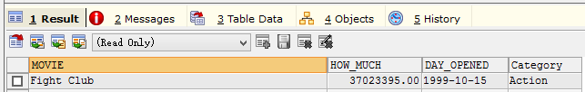

c) Insert a new tuple in APPEARED_IN table, with values (“Matt Damon”, “Bruce Almighty”).

|  |
| --- |
| **insert** **into** appeared_in **values(**'Matt Damon'**,** 'Bruce Almighty'**);** |

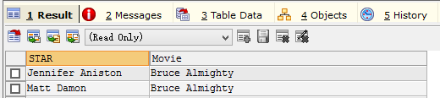

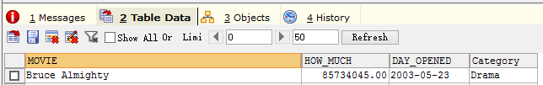

d) Insert a new tuple in MARRIED, with values (1, 2015-06-26).

|  |
| --- |
| **insert** **into** married **values(**1**,**20150626**);** |

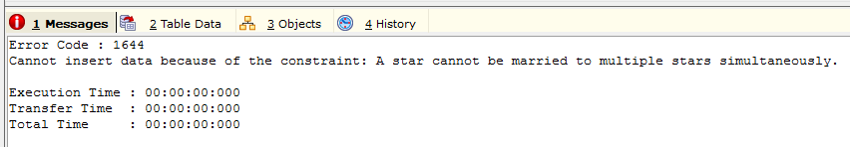

e) Insert two new tuples in MADE_MONEY, having values (“Most Welcome”, 8000, 2012-07-07, “Action”) and (“Speed”, 9000, 2010-03-28, “Comedy”).

|  |
| --- |
| **insert** **into** made_money **values** **(**'Most Welcome'**,** 8000**,** 20120707**,** 'Action'**);**  **insert** **into** made_money **values** **(**'Speed'**,** 9000**,** 20100328**,** 'Comedy'**);** |

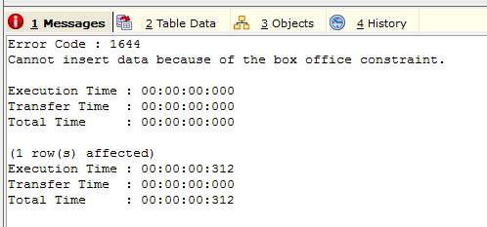s

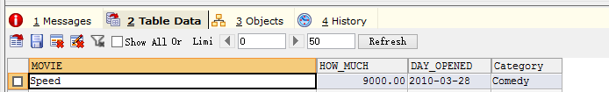

f) Insert a new tuple in MADE_MONEY, having values (“Hangover”, 1500000000, 2011-03-05, “Comedy”).

|  |
| --- |
| **insert** **into** made_money **values** **(**'Hangover'**,** 1500000000**,** 20110305**,** 'Comedy'**);** |

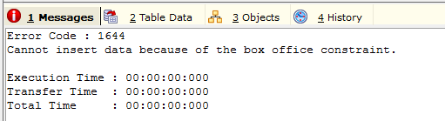

g) Insert a new tuple in DIVORCED, with values (6, 2004-01-01).

|  |
| --- |
| **insert** **into** divorced **values** **(**6**,** 20040101**);** |

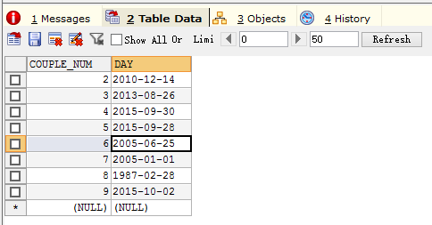

After performing the above statements, the LOG_DATA Table is:

